**CREATE LIBRARY THAT WILL USE THE WEB SERVICE**

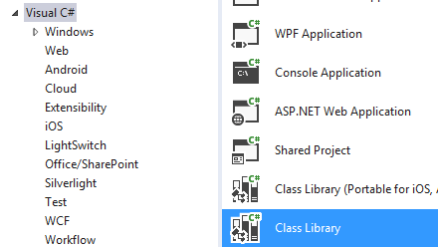

**Esta es la libreria que agregara en el projecto de hotbar**

**Esta es una dll que hace el llamado al web service**

**Hotbar lo que tendra es la dll**

**Debe actualizar la nueva referencia, al web service actualizado en el server**

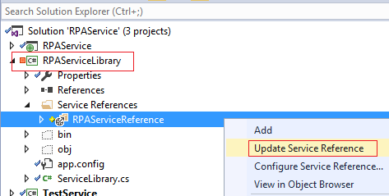

**Agrega la referencia al web service de la misma forma como lo hizo en la parte previa**

APP.CONFIG

<?xml version="1.0" encoding="utf-8" ?>

<configuration>

<system.serviceModel>

<bindings>

<basicHttpBinding>

<binding name="BasicHttpBinding_IRPAService" /> PARA LOCAL

<binding name="BasicHttp**s**Binding_IRPAService"> PARA REMOTO

<security mode="Transport" />

</binding>

</basicHttpBinding>

</bindings>

<client>

PARA USARLA COMO LOCAL

<endpoint address="http://localhost:53258/RPAService.svc"

binding="basicHttpBinding"

bindingConfiguration="BasicHttpBinding_IRPAService"

contract="RPAServiceReference.IRPAService"

name="BasicHttpBinding_IRPAService" />

PARA USARLA REMOTO

<endpoint address="https://localhost:44341/RPAService.svc"

binding="basicHttpBinding"

bindingConfiguration="BasicHttp**s**Binding_IRPAService"

contract="RPAServiceReference.IRPAService"

name="BasicHttpsBinding_IRPAService" />

</client>

</system.serviceModel>

</configuration>

Add reference

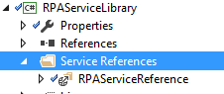

Update any change

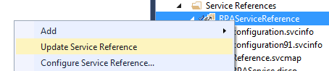

To set to the correct server when the web service is

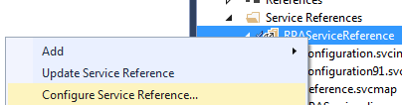

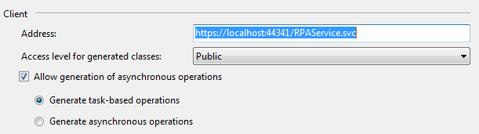

**En el programa principal de la libreria se hace las referencias a los metodos a usar del web service**

using log4net;

using RPA.RPAServiceReference;

using System;

using System.Collections.Generic;

using System.Reflection;

namespace RPA

{

public static class ServiceLibrary

{

private static ILog log = LogManager.GetLogger(MethodBase.GetCurrentMethod().DeclaringType);

public static ATTSiteSettings GetATTSite(string workstation)

{

ATTSiteSettings details = null;

try

{

using (RPAServiceClient client = new RPAServiceClient())

{

details = client.GetATTSite(workstation);

}

}

catch (Exception ex)

{

log.Error(ex);

}

return details;

}

public static List<ATT_Tips> GetTips()

{

List<ATT_Tips> details = null;

try

{

using (RPAServiceClient client = new RPAServiceClient())

{

var settings = client.GetTips();

foreach (var item in settings)

{

ATT_Tips ss = new ATT_Tips();

ss.TIP = item.TIP;

ss.LINK = item.LINK;

details.Add(ss);

}

}

}

catch (Exception ex)

{

log4net.Config.XmlConfigurator.Configure();

log.Error(ex.ToString());

}

return details;

}

}

}

Otra opcion de GetTips

public static DataTable GetTips()

{

DataTable dtTips = new DataTable();

dtTips.Columns.Add("TIP", typeof(string));

dtTips.Columns.Add("LINK", typeof(string));

try

{

using (RPAServiceClient client = new RPAServiceClient())

{

var settings = client.GetTips();

foreach (var item in settings)

{

dtTips.Rows.Add(item.TIP, item.LINK);

}

}

}

catch (Exception ex)

{

log4net.Config.XmlConfigurator.Configure();

log.Error(ex.ToString());

}

return dtTips;

}

**Genere nuevo release (no debug) y copie la dll**

C:\Proyectos\Hotbar 2\RPAService2\RPAServiceLibrary\bin\Release

RPAServiceLibrary.dll

A

C:\Proyectos\Hotbar 2\Hotbar\ServiceLibrary

**Dele Commit para subirlo a SVN y luego en Proyecto Hotbar refresque con “Update to Lastest Version”**

